Umbrella's Brutality: The Horror That Refuses to Stay Dead
By Swetha on June 27 at 11:23 am IST

A single bite. An abandoned mansion. A city wiped off the map.
Resident Evil isn't just another zombie game, it's a nightmare that has haunted gamers for nearly three decades. Since its debut in 1996, Capcom's legendary survival horror franchise has terrified millions with its creepy atmosphere, unforgettable monsters, and stories filled with betrayal, experiments, and biological disasters.
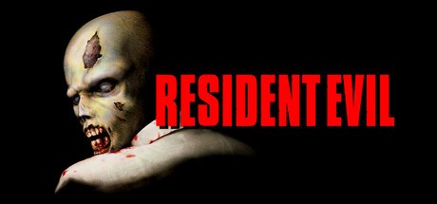

What makes Resident Evil special isn't just the zombies. It's the constant feeling that danger is always around the corner. Every locked door, every dark hallway, and every strange noise makes you question whether taking the next step is worth the risk. Even after all these years, the franchise continues to prove why it's one of the greatest horror series ever created.
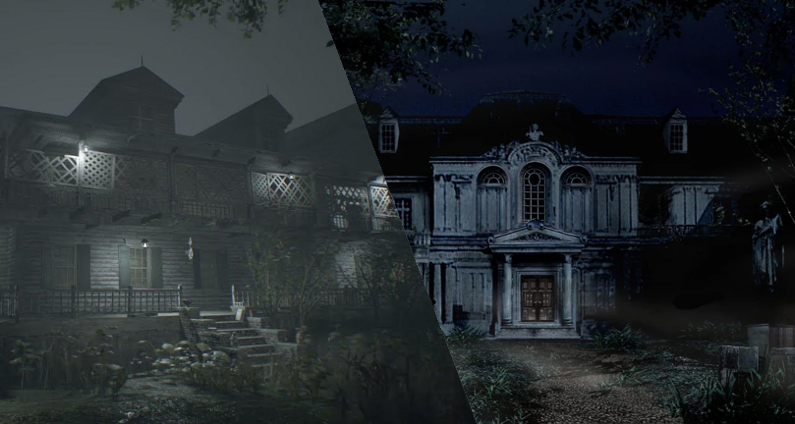
The Perfect Balance of Horror and Action
Unlike many action games, Resident Evil doesn't let players feel safe for long.
Every location feels like a puzzle waiting to trap you. From the eerie Spencer Mansion to the abandoned Raccoon City Police Department and the haunting Baker estate, every environment is designed to make players feel isolated and vulnerable.
Limited ammunition and healing items mean that every decision matters. Should you fight the creature blocking your path or save your bullets for something even worse? That constant pressure keeps the tension alive from beginning to end.
The game also knows how to use silence. Sometimes, the absence of music is far more terrifying than loud jump scares. A slow creaking door or distant footsteps can be enough to make players hesitate before moving forward.
Characters You'll Never Forget

Resident Evil wouldn't have become the iconic series it is today without its unforgettable characters.
Leon S. Kennedy begins as an inexperienced police officer caught in a nightmare but grows into one of gaming's most respected heroes.
Jill Valentine is fearless under pressure and repeatedly proves why she's one of the strongest survivors in the series.
Claire Redfield's determination to protect the people she loves makes her one of the franchise's most relatable protagonists, while Chris Redfield's relentless fight against bioterrorism shows his unwavering commitment to stopping future outbreaks.
Then there's Ada Wong, a woman surrounded by mystery. Her secret missions, unpredictable choices, and complicated relationship with Leon keep fans guessing in every appearance.
Each character brings a unique perspective to the horrifying world of Resident Evil, making every game feel fresh while remaining connected.

More Than Just Zombies

Behind every terrifying outbreak lies one name: the Umbrella Corporation.
Disguised as a pharmaceutical company, Umbrella secretly conducted illegal experiments that gave birth to deadly viruses and horrifying bio-organic weapons. Their greed turned ordinary people into monsters and transformed Raccoon City into one of gaming's most unforgettable tragedies.
As the series expanded, new organizations, viruses, and conspiracies emerged, revealing that Umbrella's influence stretched far beyond a single city.
One of my favorite aspects of Resident Evil is how every game answers one question while creating several new mysteries. Hidden files, secret laboratories, and shocking plot twists encourage players to keep exploring the franchise, making the lore just as addictive as the gameplay itself.

Gameplay That Keeps Evolving
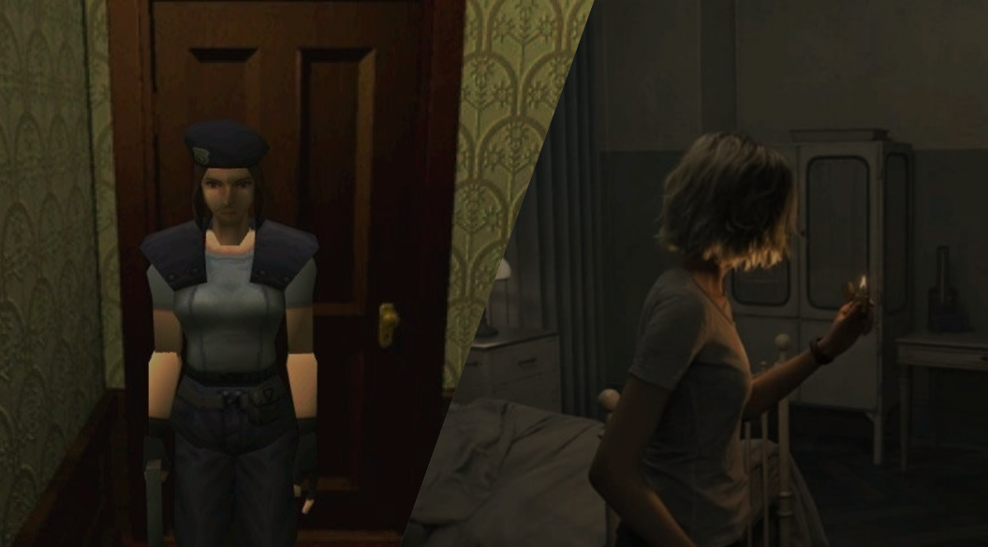
Resident Evil has changed dramatically over the years while staying true to its survival horror roots.
The original games used fixed camera angles that made every hallway feel claustrophobic and unpredictable.
The modern remakes have also introduced a new generation of players to classic stories with improved graphics, smoother gameplay, and even more immersive environments.
Very few franchises can stay relevant for almost thirty years, but Resident Evil continues to do exactly that.
It isn't just about zombies or monsters, it's about surviving against impossible odds, uncovering terrifying secrets, and facing fears hidden behind every locked door.

Whether you're escaping Raccoon City, exploring an abandoned mansion, or confronting Umbrella's horrific experiments, Resident Evil delivers an experience that stays with you long after the credits roll.
For me, that's what makes Resident Evil more than just a game. It's a horror journey that refuses to stay dead.

